**Git** and **github**

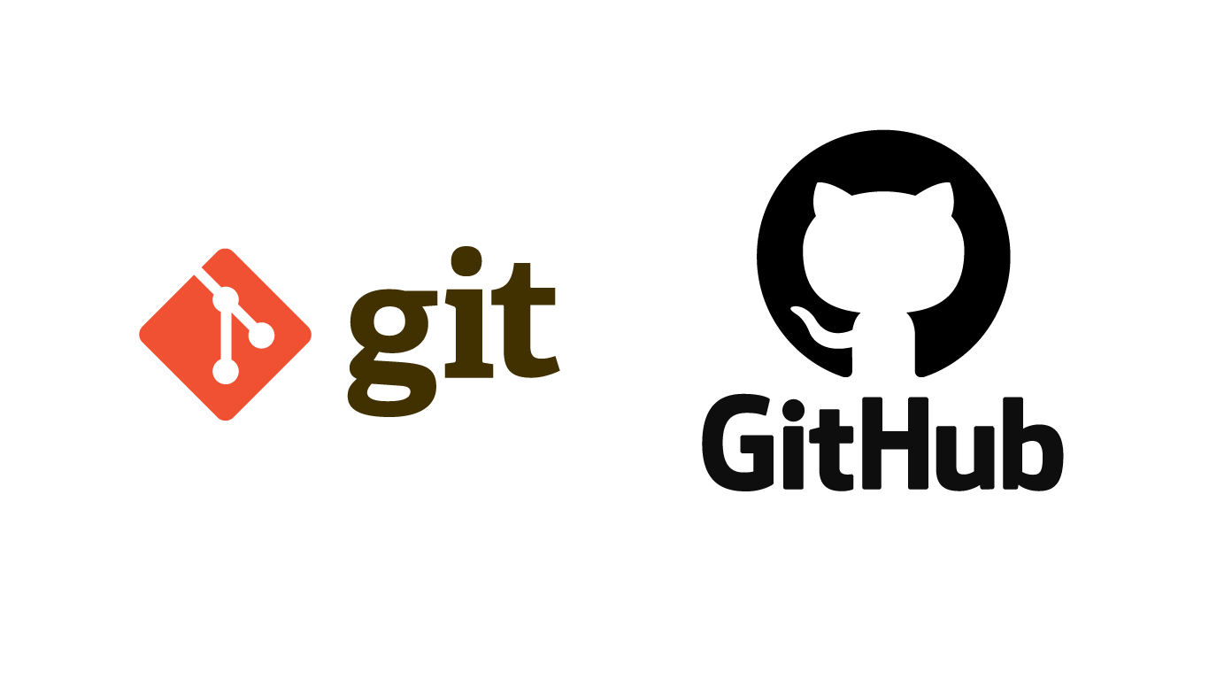

I - git

what is git ?

Git is a version control system developed by Linus Torvalds in 2005 (the same guy who wrote Linux). Git helps developers keep track of the state of their code and allows collaboration on a codebase.

II – github

What is hithub ?

Github is a free (for personal use), cloud-hosted platform for code. It works with Git on your and your colleagues' computers, serving as the **origin**, the source of truth for anyone working on the code.

You and your collaborators upload their code to GitHub periodically, and GitHub provides tooling to help manage changes to the code over time.

